Title of work : Query response II

Duration : 8min

Program Notes / Description (200 words maximum) :

Queries and responses are what you always see in your daily life. Questions and answers are issued by people and also by digital equipments. A digitally empowered piano also sometimes issues queries to obtain sonified responses from a computer. The first version of this piece is commissioned by and dedicated to Hiroaki OOI, who studied electronics at Kyoto University with KITA (the composer) some decades ago. It was premiered by OOI (piano) and KITA (smartphone), and this time totally re-coded for a MIDI piano and smartphones.

Spatial diagram for installation and multichannel music submission :

Two small speakers (as in the second picture below; i will use my own) that are positioned near a MIDI piano (acoustic or digital). The piano is played by MIDI data from Csound. The piano sound is taken by a small microphone (also my own) and is processed by Csound to bed fed back to the environment through the two small speakers (directed to the audience and to the wall).
Basically no speakers prepared at the venue are used, but i might need to use some if my own speakers are not appropriate (too small) for the concert venue.
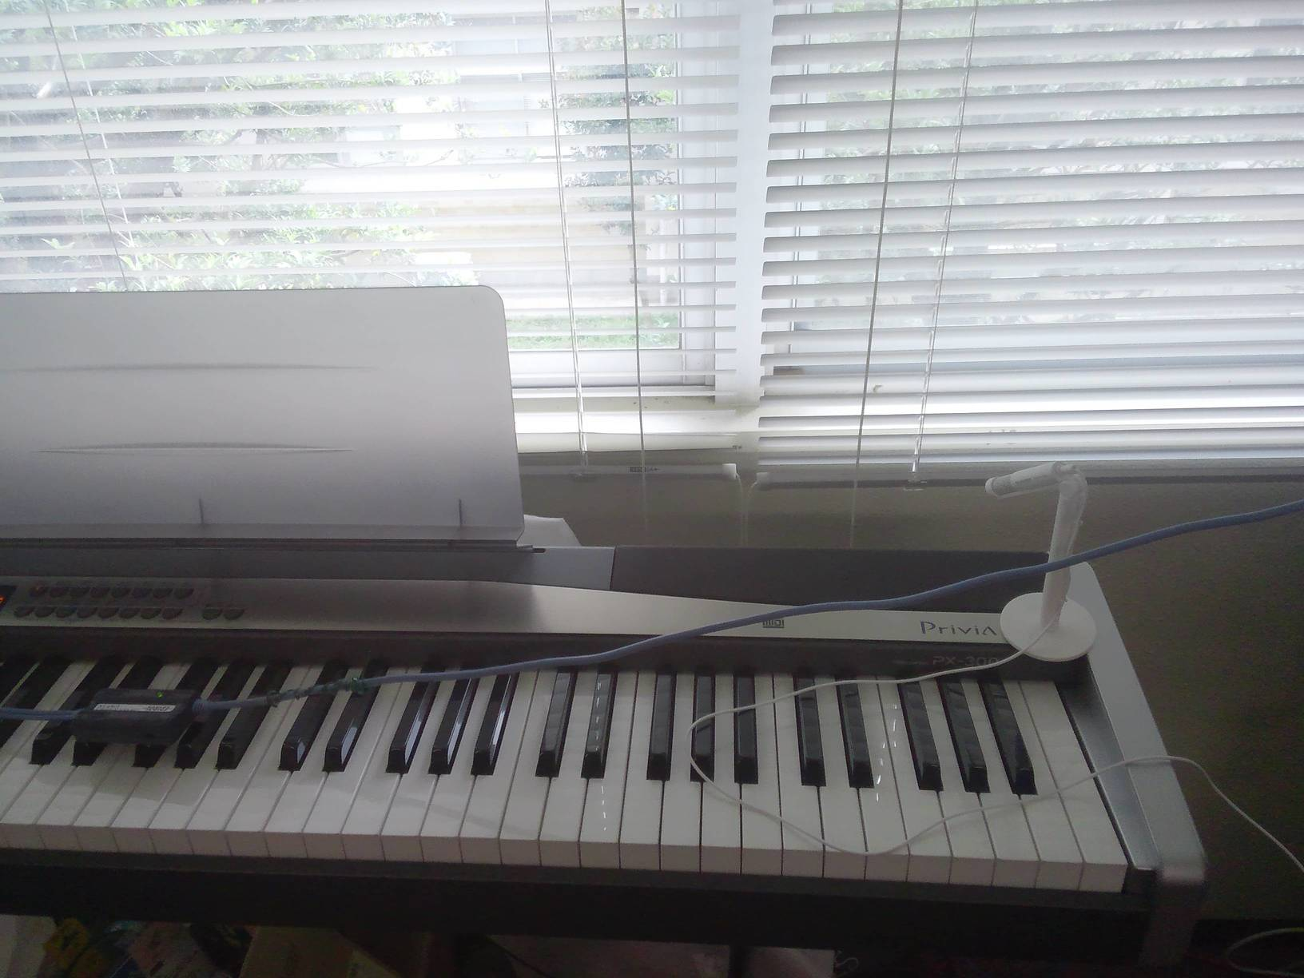

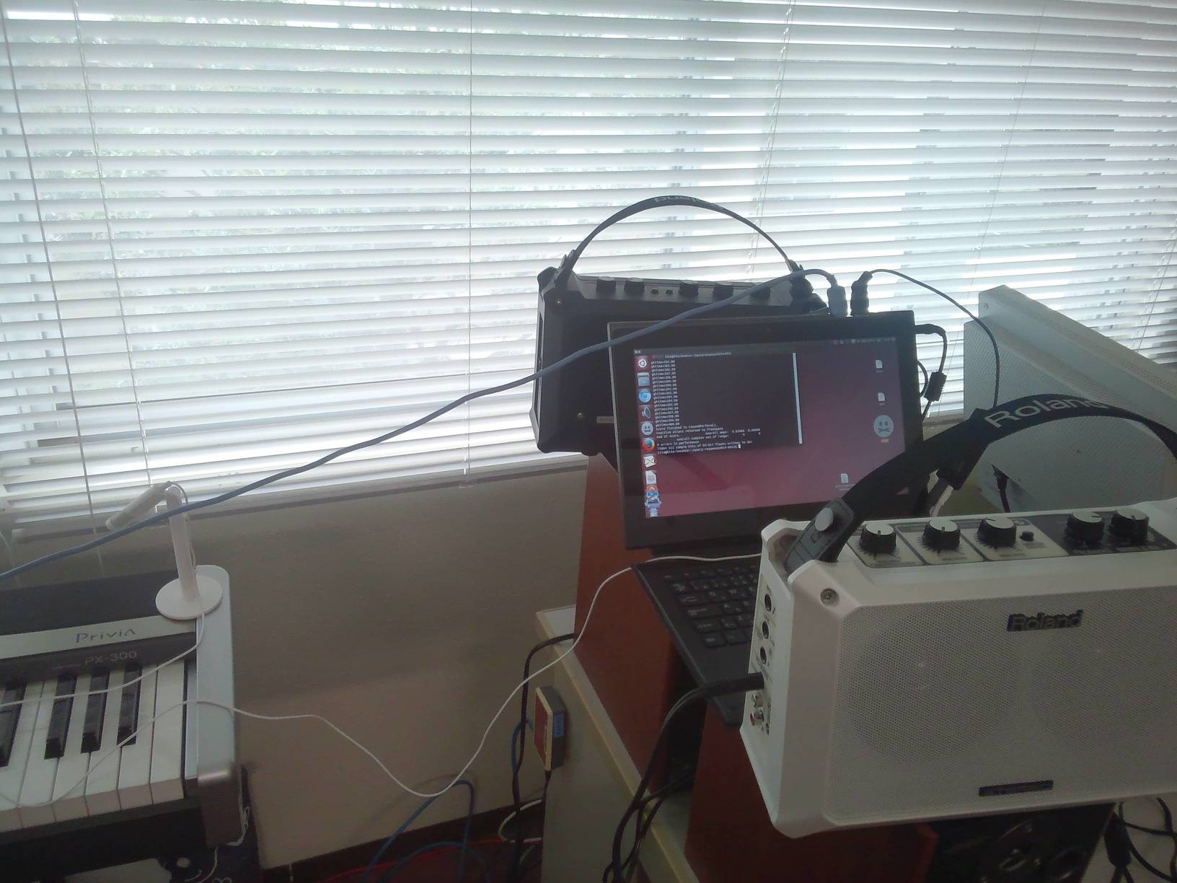

Any other additional technical specifications :

A Wifi router (i will use my own) is used for accepting manipulation data from audience smartphones.

Files (Not yet completed) :

query-response-oldversion1-demo.mp3 : demo sound of the first version (not this submitted piece) created by using software piano

query-response1.csd : CSD file for the first version of the piece. (not this version)

Contact information :

Toshihiro Kita kita@ield.kumamoto-u.ac.jp
Born in Nara in 1967. Professor at the Institute for e-Learning Development, Kumamoto University, Japan. Ph.D. in Engineering (Nagoya University, 2005). Fields of interest: e-learning systems, nonlinear systems, electronic music. JSSA (Japanese Society for Sonic Arts) and ACMP (Asia Computer Music Project) board member.
Website: http://tkita.net/

